Mike Martin

Mike Martin has over 30 years’ experience working in health, housing and social care. Before retiring in 2011 he was Director of the Joint Improvement Team in the Scottish Government.  Mike has been chair of Hanover since July 2014. | 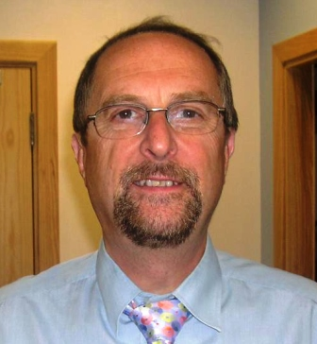
Date of 1st Appointment  (co-opted or elected) | 08.07.05

Geoff Palmer
Professor Emeritus Geoff Palmer began his academic career at the Heriot Watt University as a lecturer in 1977 and became Professor of Grain Science and Technology in 1990.  Professor Palmer has a long and active interest in Community service. | 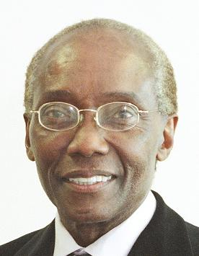
Date of 1st Appointment  (co-opted or elected) | 08.06.01

Stephen Lithgow
Stephen is an occupational therapist who has worked for 15 years in older adults’ mental health. He now works with the Focus on Dementia Team at Health Care Improvement Scotland. His interests are around Dementia, Post Diagnosis Support, Policy and Dementia Networks.

Date of 1st Appointment  (co-opted or elected) | 30.11.17

Fraser Mitchell
Fraser has held various operational and strategic management positions in Social Work services in Strathclyde and Fife, mainly in multi-disciplinary teams involving close partnership working with Health and the independent sector.

Date of 1st Appointment  (co-opted or elected) | 30.11.17

Jo Roger
Jo has worked for over 15 years in HR leadership and organisational change in consulting, technology and financial services organisations. Jo is currently working as an interim Deputy Director of HR at the University of Edinburgh and sits on the Development Advisory Group for a mental health charity.

Date of 1st Appointment  (co-opted or elected) | 27.09.18

James Rowney

James is Head of Solutions at the Royal Bank of Scotland. His team provides specialist advice to corporate and commercial customers at critical times. He has a keen interest in housing and has been involved in many aspects of it over a number of years.

Date of 1st Appointment  (co-opted or elected) | 28.09.17

Margaret Whoriskey
Margaret leads the national programme, on the Scottish Government, to drive adoption of new technology to support health and social care service transformation. She is responsible for the national Technology Enabled Care Programme which is aiming to support at scale deployment in Scotland.

Date of 1st Appointment  (co-opted or elected) | 15.03.18

Gary Devlin
Gary is a qualified chartered accountant and a partner in Scott Moncrieff where he is Head of the Public Sector. Gary has over 20 years experience with charities, housing associations, education and public sector organisations. He is a past chair of CIPFA Scotland and a member of the Local Authority (Scotland) Accounts Advisory Board. | 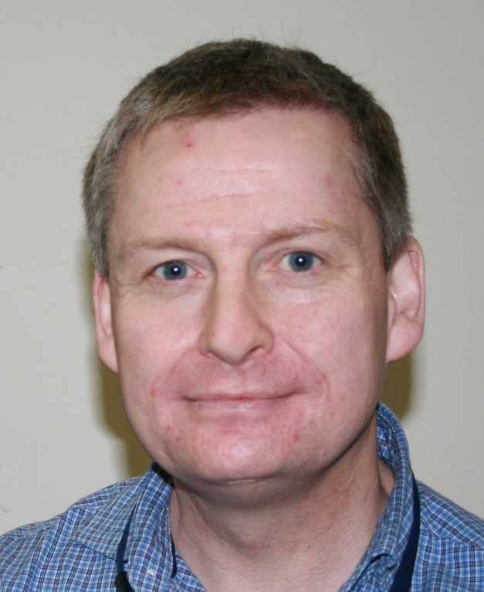
Date of 1st Appointment  (co-opted or elected) | 28.11.13

Cathie Wyllie
Cathie is a chartered accountant with over 30 years audit and consultancy experience working in practice with housing associations, charities and public sector organisations. Cathie has a special interest in governance and risk management. She currently leads the internal audit and counter fraud teams in Angus Council.

Date of 1st Appointment  (co-opted or elected) | 26.09.13

Louise Reid

Louise is a Senior Lecturer in Sustainable Development and Geography at the University of St Andrews and has been with the University since 2010.
Louise holds an interest in human geography and her research into housing design and new technology is identifying new ways to improve quality of life for families and individuals. Her research also looks at placing the home at the centre of everyday life and identifies how to make housing more sustainable in the future.
Alongside her role as Senior Lecturer, Louise is also the Director of the Centre for Housing Research (CHR), a research centre which looks at two main strategic areas in housing:
Homes, Families & Communities
Places, Policies & Practices
Date of 1st Appointment  (co-opted or elected) | 26.09.19

