# Accessing the External Hub

You can access the Hub from anywhere. You can use any device that will have internet access e.g. mobile phone, tablet/iPad/Surface, laptop, PC etc. but there may be restrictions on what you can do depending on the device you use. Below is listed what isn’t possible on the relevant devices.

|  |  |  |  |
| --- | --- | --- | --- |
|  | **Mobile Phone** | **Tablet / iPad / Surface** | **Laptop / PC** |
| **Open documents e.g. Instructions** | **×** | **×** | **×** |
| **Add attachments within HR portal or Team portal** | **×** | **×** | **×** |
| **Add notes (using the notes button) within HR portal or Team portal** | **×** | **×** | **×** |
| **Charge mileage or claim to another department or development** | **×** | **×** | **×** |
| **Email your payslip** | **×** | **✓** | **✓** |
| **Amend an expense or mileage claim** | **×** | **✓** | **✓** |
| **Delete an expense or mileage claim** | **×** | **✓** | **✓** |

Although you won’t be able to do any of the above that is marked as “Not possible” when accessing the external hub, you will still be able to view your payslip, request annual leave and submit mileage or expense claims.

1. Open your internet browser and go to <https://thehubexternal.hanover.scot/>
2. Log in using the same username and password that you use when you are logging into the computer when you are at work.

**NB your username must be prefixed with atlantic\ (as demonstrated in the picture below)**

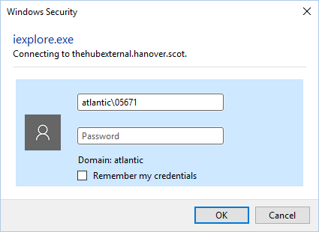

1. Click on “OK”