AGM 2022

ELECTION OF BOARD MEMBERS

- INTRODUCTION

  - This year there are three existing Board members standing for election to the Board.

- BOARD MEMBERS STANDING FOR RE-ELECTION

  - As per Rule 39.1, the three Members standing down by rotation are:

- Louise Reid
- James Rowney
- Margaret Whoriskey

2.2 All three members have declared their willingness to serve again and in accordance with Rule 40.1 do not require to be formally nominated. Their profiles are detailed below for information:

Louise Reid

Louise has been a Board Member since 2019 and was appointed Vice-Chair last year.

Louise has been a Senior Lecturer in Sustainable Development and Geography at the University of St Andrews since 2010. She holds an interest in human geography and her research into housing design and new technology is identifying new ways to improve quality of life for families and individuals. Her research also looks at placing the home at the centre of everyday life and identifies how to make housing more sustainable in the future. Louise is also the Director of the Centre for Housing Research (CHR).
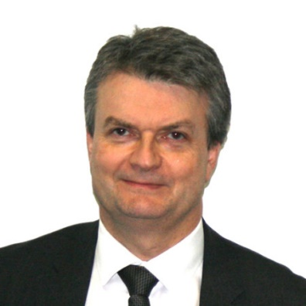
James Rowney

James has been a Board Member since 2017 and sits on the APR Committee.

James is Head of Solutions at the Royal Bank of Scotland. His team provides specialist advice to corporate and commercial customers at critical times. He has a keen interest in housing and has been involved in many aspects of it over a number of years.
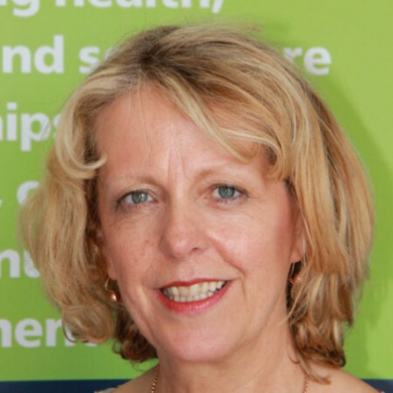
Margaret Whoriskey

Margaret has been a Board Member since 2018 and sits on the APR Committee.

Margaret is employed by the Scottish Government leading the national programme to drive adoption of new technology to transfer health and social care. She is responsible for the national Technology Enabled Care Programme which is aiming to support at scale deployment in Scotland.

