Ref: GD/WR/EMM

31 August 2022

Dear Member

Annual General Meeting 2022

On behalf of Hanover, I am pleased to inform you that the Annual General Meeting of Hanover Scotland will be held virtually, over Microsoft Teams, on:

Thursday 22 September 2022, commencing at 1.00pm.

Given the highly popular Customer Strategy Roadshows that Hanover have been holding, across the country during July and August, we felt that a virtual AGM meeting, with only Hanover members attending, would be the best option for this year.

Please find enclosed the relevant paperwork pertaining to the AGM which is:

• RSVP Form - this sets out a number of ways for you to either register your attendance or give us your apologies. It also helps you to ensure that you nominate a proxy for your vote if you are unable to attend but would like to vote. Please note we are looking for your RSVP to be with us no later than Thursday 15 September 2022. There will also be an option on there for you to do a trial run to join the meeting.
• Agenda
• Minutes of AGM 2021
• Annual Financial Statements 2021-22
• Election of Board Members Paper

If you confirm that you do want to attend using the RSVP form / online options, we will arrange for the joining instructions for the meeting to be emailed to you.

We look forward to seeing you at the meeting.

Yours sincerely

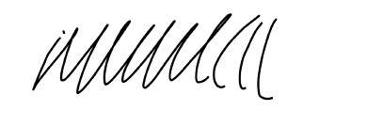
Wendy Russell
Company Secretary

Enc

