Board Meeting Minutes

Minutes of a meeting held at 1.40pm on Thursday 22 September 2022 via Microsoft Teams

Present Gary Devlin (Chair), Ashley Campbell, Julia Fitzpatrick, Adele Erwin, James Rowney, Rob Rowe, Louise Reid

In attendance Angela Currie (Chief Executive), Wendy Russell (Director of Business Support & Transformation)

Apologies Alan Stewart, Fraser Mitchell, Jo Roger, Cathie Wyllie, Margaret Whoriskey
_______________________________________________________________________________

1. | Introduction & Apologies
 | The Chair welcomed Board Members to the meeting. Apologies were accepted from Alan Stewart, Fraser Mitchell, Jo Roger, Cathie Wyllie, Margaret Whoriskey.
2. | Declarations of Interest
 | As the Committees and Office Bearers were being appointed along with the Company Secretary, all Members had an interest, as did Wendy Russell.
3. | Appointment of Chair & Vice Chair of Hanover Scotland
Discussion | WR conducted the first part of this item. WR confirmed that Gary Devlin was willing to stand as Chair for another year. The Board approved that proposal. WR then handed over the rest of the agenda to the Chair.  The Chair confirmed that Louise Reid was happy to stand as Vice Chair for another year. The Board approved that proposal.
Decision | The Board appointed Gary Devlin as Chair and Louise Reid as Vice Chair.
4. | Appointment of Membership & Office Bearers for Committees
Discussion | The Chair highlighted for members the proposed membership and office bearers for both the Audit, Performance and Risk Committee and the People Committee – as per Appendix 1 of the paper. The proposal given was following individual discussions with Board Members during the 2022 Appraisal process.
Decision | The Board approved:  - Julia Fitzpatrick as the Chair and James Rowney as Vice Chair of the Audit Performance & Risk Committee. Membership of the Committee is as follows  - Julia Fitzpatrick  - James Rowney  - Adele Erwin  - Fraser Mitchell  - Margaret Whoriskey  - Cathie Wyllie  - Jo Roger as the Chair of the People Committee. It was agreed that a Vice Chair would be considered at a later date. Membership of the Committee is as follows  - Jo Roger  - Gary Devlin  - Ashley Campbell  - Alan Stewart
5. | Appointment of Company Secretary
Discussion | The Chair presented the proposal that the Company Secretary role should be linked to the role of Director of Business Support & Transformation.
Decision | The Board approved Wendy Russell, in her role as Director of Business Support & Transformation to carry out the role of Company Secretary.
6. | Appointment of Data Protection Officer
Discussion | The Chair presented the proposal that the Data Protection Officer role should continue to be linked to the role of Head of Governance & Transformation.
Decision | The Board approved Elaine McCaffery, in her role as Head of Governance & Transformation to carry out the role of Data Protection Officer.
7. | Any Other Competent Business
 | None.

Chairperson: Gary Devlin

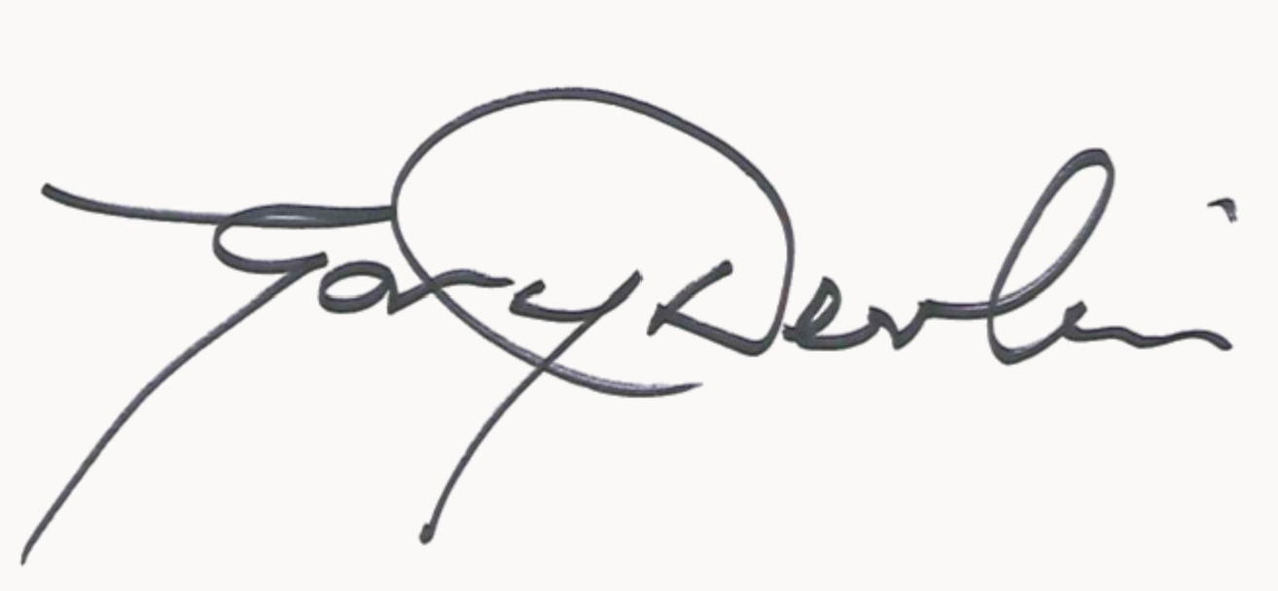

Date: 27.10.22

